NAMA KELOMPOK 8 :
- INDIRA CARISA DEWI(20051214011)
- RIZANIA FAYZAA INDHIRA (20051214039)
- LAILATUL MUKHARROMATUS SA’DIYAH(20051214051)
- KURROTUL UYUN(20051214093)

Diagram UML dan Hasil Uji Coba

- Diagram UML
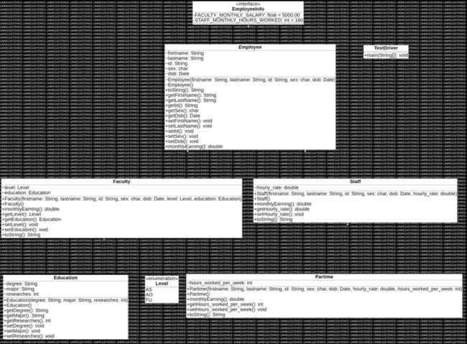

- Hasil Uji Coba
Employee
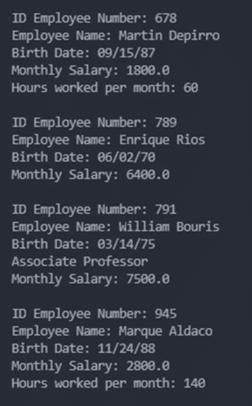
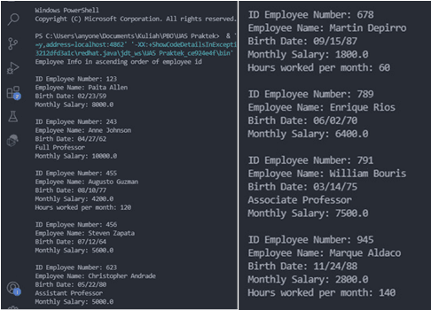

Staff Faculty
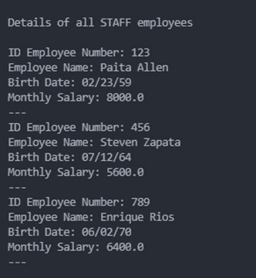
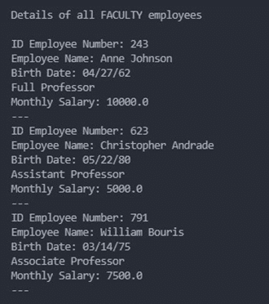

Part Time
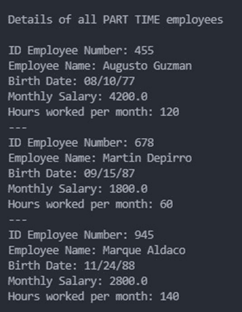

Total

